# ITP 449 Fall 2019

# Homework 1 30 points

Name: Maxwell Lee

For each one of the following questions, write Python code in PyCharm. For your answers paste your Python code and a screenshot of the output in this document and submit on Blackboard.

1. Write a program that prompts the user to enter a password then prints the length of the password.

*Enter your password: hello*

*Your password is 5 long.*

password = input(**"Enter a password "**)  
length = len(password)  
print(**"Your password is"**, length, **"characters long."**)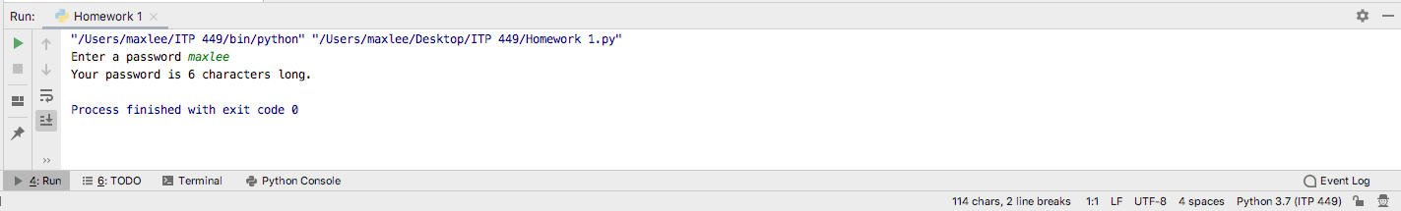

1. Write a program that prompts the user to enter their full name then prints the number of characters in their name (do not count spaces).

*What is your name? Nitin Kale*

*Nitin Kale your name has 9 characters.*

name = input(**"Enter your name "**)  
lengthname = len(name.replace(**" "**, **""**))  
print(**"Your name is"**,lengthname , **"characters long."**)

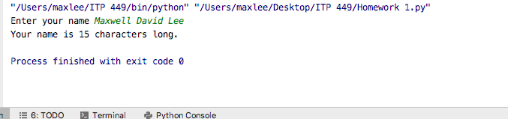

1. Write a program that prompts the user to enter a month (as a number), then prints the name of the month and the number of days in that month.

*Enter the month number: 9*

*September has 30 days*

month = int(input(**"Enter the month number: "**))  
**if** month == 1:  
 print(**"January has 31 days"**)  
**elif** month ==2:  
 print (**"February has 28 or 29 days"**)  
**elif** month == 3:  
 print(**"March has 31 days"**)  
**elif** month == 4:  
 print(**"April has 30 days"**)  
**elif** month == 5:  
 print(**"May has 31 days"**)  
**elif** month == 6:  
 print(**"June has 30 days"**)  
**elif** month == 7:  
 print(**"July has 31 days"**)  
**elif** month == 8:  
 print(**"August has 31 days"**)  
**elif** month == 9:  
 print(**"September has 30 days"**)  
**elif** month == 10:  
 print(**"October has 31 days"**)  
**elif** month == 11:  
 print(**"November has 30 days"**)  
**elif** month == 12:  
 print(**"December has 31 days"**)  
**else**:  
 print(**"That month does not exist"**)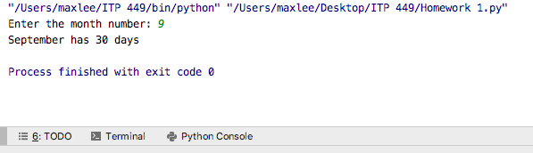

1. Write a program that prompts the user to enter a loan amount, interest rate, and number of years for a car loan. Then it prints the monthly payment amount.

*Loan Amount: 30000.00*

*Annual Interest Rate: 4.00*

*Years: 5*

*Your monthly payment is: $552.50*

principle = float(input(**"Loan amount: "**))  
interest = float(input(**"Interest rate: "**))  
years = float(input(**"Years: "**))  
  
monthlyir = (interest/100)/12  
monthlypayment = (monthlyir + (monthlyir/((1+monthlyir)**(years*12)-1)))*principle  
finalpay = round(monthlypayment,2)  
  
print(**"Your monthly payment is: $"** + str(finalpay))

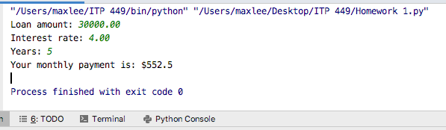

1. Write a program to that prompts the user to enter their first name. It then prints whether or not their name is a [palindrome](https://en.wikipedia.org/wiki/Palindrome).

*What is your name? Nitin*

*Nitin, your name is a palindrome!*

name = input(**"What is your name? "**)  
lowername = name.lower()  
stringlength = len(lowername)  
reversename = lowername[stringlength::-1]  
  
**if** lowername == reversename:  
 print(name + **", your name is a palindrome!"**)

